
RAMAIAH
Institute of Technology
USN | 1 | M | S

(Autonomous Institute, Affiliated to VTU)
(Approved by AICTE, New Delhi & Govt. of Karnataka) Accredited by NBA & NAAC with ‘A’ Grade

MAKE UP EXAMINATIONS – APRIL 2021
Program | : | B.E. : Computer Science and Engineering | Semester | : | III
Course Name | : | Theory of Computation | Max. Marks | : | 100
Course Code | : | CS34 | Duration | : | 3 Hrs

Instructions to the Candidates:
- Answer one full question from each unit.

 |  | UNIT- I
1. | a) | Define: i) Strings, ii) Alphabet, iii) Language, iv) Power of an alphabet, v) Concatenation of strings. | CO1 | (05)
 | b) | Define deterministic finite automata. Design a DFA for the language which accept strings of a's and b's with utmost two consecutive b's. Show the processing of the string aabbab. | CO2 | (07)
 | c) | Construct a DFA equivalent to the following ε-NFA .  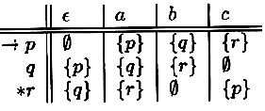 | CO3 | (08)
2. | a) | Convert the NFA below to an equivalent DFA.  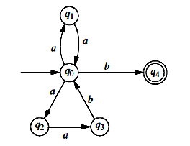 | CO3 | (08)
 | b) | Prove that a language L is accepted by some DFA if and only if it is accepted by some NFA. | CO4 | (06)
 | c) | Define the extended transition function of an ε-NFA. Trace the sequence of moves made by the ε -NFA below on the input string “aab”.  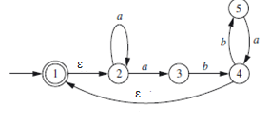 | CO1 | (06)
 |  | UNIT – II
3. | a) | Define regular expression. Give the regular expression for the following languages over {0, 1}*  - Strings that begin or ends with 00.  - Strings having odd number of 1’s | CO3 | (04)
 | b) | Prove that if L is regular so is L^{R}. Illustrate this with an example. | CO4 | (08)
 | c) | For the given DFA use the minimization algorithm to find a minimum-state DFA. | CO3 | (08)
  State | a | b
  →q0 | q1 | q2
  q1 | q1 | q3
  q2 | q1 | q2
  q3 | q1 | *q4
  *q4 | q1 | q2
4. | a) | Convert the following DFA to regular expression using state elimination method.  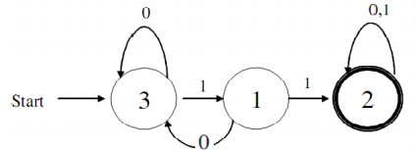 | CO3 | (06)
 | b) | Prove that every language defined by a regular expression is also defined by a finite automaton. | CO3 | (05)
 | c) | State and prove pumping lemma for regular language. Show that the language L= {a^{i} b^{j} | i>j} is not a regular language. | CO4 | (09)
 |  | UNIT – III
5. | a) | Construct CFG for the following language:  i)L={a^{i}b^{j}| i≤2j}  ii)L={a^{i}b^{j}c^{k}|i≠j or j≠k} | CO2 | (06)
 | b) | Let G=(V,T,P,S) be a CFG. Prove that if the recursive inference procedure tell us that terminal string w is in the language of variable A, then there is a parse tree with root A and yield w. | CO4 | (08)
 | c) | Define ambiguous grammar. Show the following grammar is Ambiguous  S S+S/S-S/S*S/(S)/S/a. | CO3 | (06)
6. | a) | Obtain the Leftmost and rightmost derivation and parse tree for the string aaabbabbba using the following grammar  S aB|bA  A aS|bAA|a  B bS|aBB|b. | CO2 | (06)
 | b) | Construct PDA to accept strings with L={a^{i}b^{j} | i j 2i} and show moves For the strings aabbbb and aaabbbbb. | CO3 | (10)
 | c) | Define the following:  - Language of CFG  - Sentential form. | CO1 | (04)
 |  | UNIT – IV
7. | a) | Design PDA for the following language accepted by final state. Also write its transition diagram and instantaneous description on the string”aaabb”.  L = { w | w Є (a,b)* and n_{a}(w) >n_{b}(w)} | CO2 | (10)
 | b) | State and prove pumping lemma for CFGs. Prove by the pumping lemma that 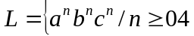 is not a CFL. | CO4 | (10)
8. | a) | Prove that if L is CFL then complement of L is also recursive language and R is a Regular language, 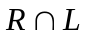is also a CFL | CO4 | (06)
 | b) | Design PDA for the following language accepted by final state. Also write its transition diagram and instantaneous description on the string ”aacccbb”. L = { a^{n}c^{m}b^{n} m ≥ 1 , n ≥ 1} | CO2 | (10)
 | c) | What are the conditions under which a PDA is called deterministic? Illustrate with an example. | CO2 | (04)
 |  | UNIT – V
9. | a) | Design a Turing Machine to accept the language { a^{n}b^{2n} | n ≥ 1}. Give the computation sequence for the input aabbbb. | CO2 | (10)
 | b) | Explain multitape Turing machines. Prove the equivalence of One-tape and Multitape TMs. | CO5 | (10)
10. | a) | Design a Turing machine to implement the function multiplication i,e TM will start with 0^{n}10^{m} on its tape & will end with 0^{nm} on the tape. | CO5 | (10)
 | b) | Define PCP. Let Σ ={0,1} A & B lists be as defined as below. Tell whether this instance has a solution: | CO5 | (06)
   | List A | List B
  i | w_{i} | x_{i}
  1 | 110 | 110110
  2 | 0011 | 00
  3 | 0110 | 110
 | c) | Write short notes on Universal Turing machine. | CO5 | (04)

****************

